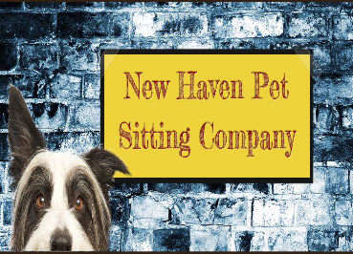
VETERINARY RELEASE FORM
In the event that any of my pets appears to be ill, injured, or at significant risk of experiencing a medical problem at the start of service or while in the care of the New Haven Pet Sitting Company (NHPSC), I give permission to NHPSC to seek veterinary service from a veterinarian or a veterinary clinic.

Veterinarian Information |  | After hours Emergency Clinic
Clinic Name: |  | Clinic Name:
Veterinarians Name: |  | Clinic Address:
Clinic Address: |  | Phone #:
Phone #:

I ask the New Haven Pet Sitting Company (NHPSC) to inform the attending clinic or veterinarian of my requested total diagnosis and treatment limit of $________________ per pet / all pets (most common values are $500, $1000, or unlimited.) I understand that efforts will be made to contact me regarding any treatments, illness, injury, or potential problems as soon as the condition is deemed not life threatening and/or contact is possible. I understand that NHPSC works hard to prevent accidents and injuries, and that such problems may occur no matter how well a pet is cared for. I agree to allow NHPSC to use their best judgment in handling these situations, and I understand that NHPSC assumes no responsibility for the actions and decisions of the veterinary staff, the health, or death of my pet(s). I will assume full responsibility for the payment and/or reimbursement for any and all veterinary services rendered, including but not limited to diagnosis, treatment, grooming, medical supplies, and boarding. Such payments will be made within 14 days of the initial incident. I also agree to be responsible for all Special Service fees assessed by NHPSC for emergency transportation, care, supervision, or hiring of emergency caregivers, and will pay such fees within 14 days of each incident. I further authorize NHPSC and my primary veterinarian(s) to share all of the medical records of all of my animals with veterinary clinics in an emergency in the interest of providing the best care for my ill or injured animal(s). Every dog(s) at the site of service will be current (per my veterinarian’s recommendation) on its rabies vaccinations. I will also make arrangements to guarantee that each animal will remain current on its rabies vaccinations throughout each service period. I agree to notify NHPSC of any signs of injury or possible illness before any service as soon as the condition appears. NHPSC reserves the right to cancel service when a pet with a potentially infectious condition exists. NHPSC strives to provide clean, safe service to each of her clients. In doing so, NHPSC strongly recommends that each pet be vaccinated, dewormed, and protected from harmful insects according to veterinarian recommended standards. This agreement is valid from the date below and grants permission for future veterinary care without the need for additional authorization each time NHPSC cares for one or more of my pets. I understand that this agreement applies to all of the pets within NHPSC’s care. In signing this contract, I agree that I have the sole authority to make health, medical, and financial decisions regarding the animals that will be scheduled to receive service.

To the Veterinary Hospital:
The New Haven Pet Sitting Company (NHPSC) has been contracted to pet sit for my pet(s) and has my permission to place them in your care in case of an emergency. NHPSC will attempt to contact me as soon as medical care is deemed necessary. However, in the event I cannot be reached immediately, I authorize you to treat my pet(s) and will be responsible for payment of any fees as stated below. Please file this form with my records.

Client/Owner Name: ____________________________________________

Client Signature: ________________________________________________ Date: ____________________

